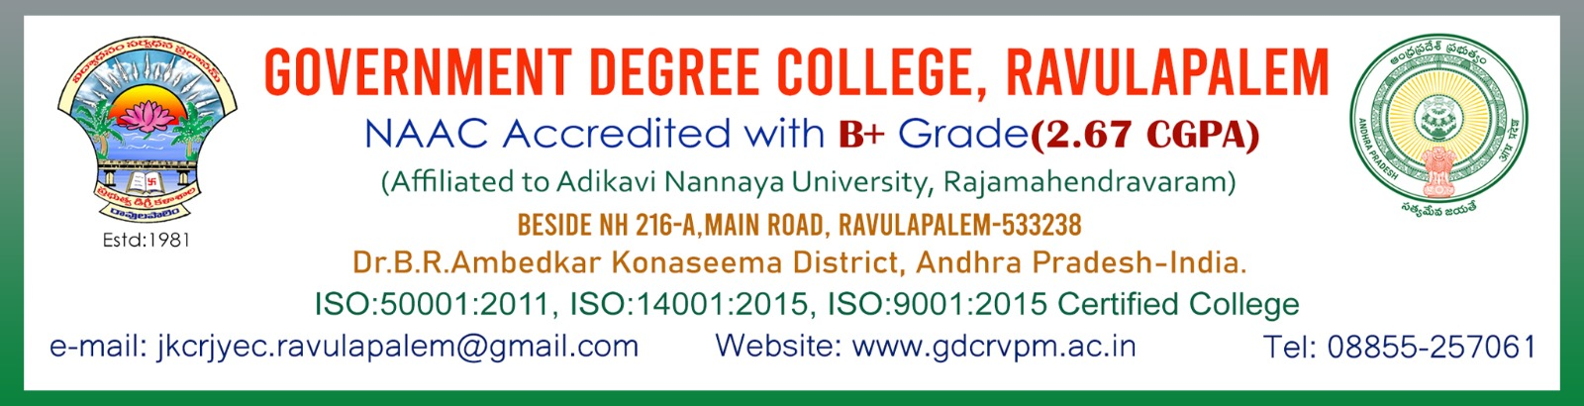

DEPARTMENT OF POLITICAL SCIENCE

INDIAN CONSTITUTION DAY

DATE:26-11-2023

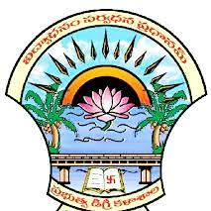

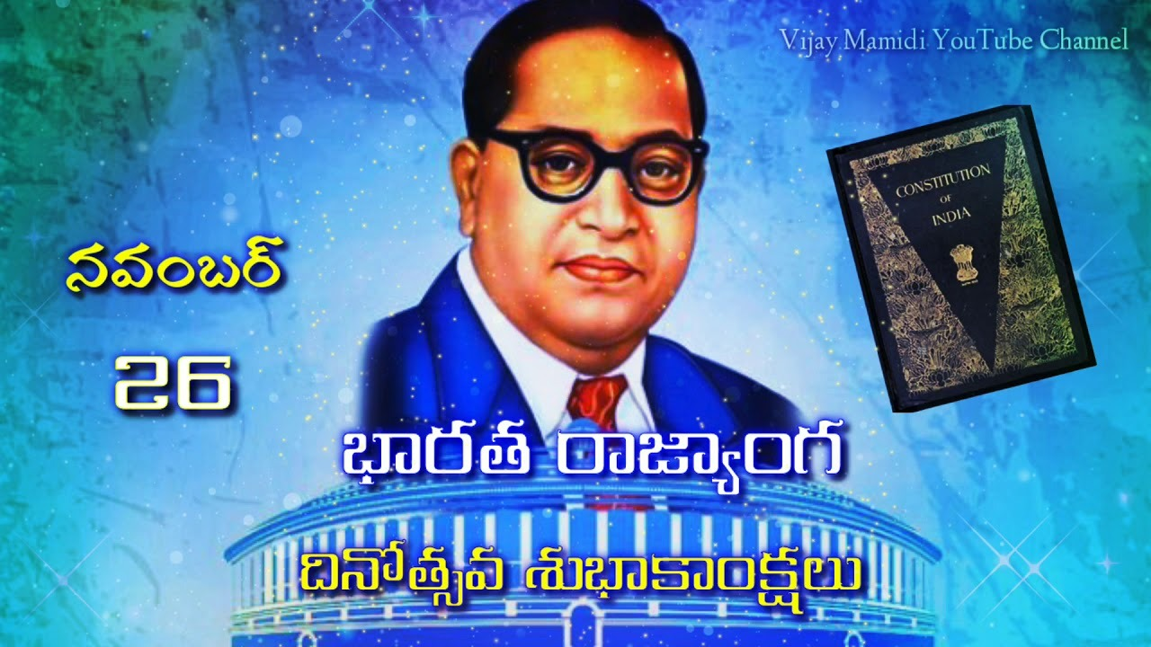

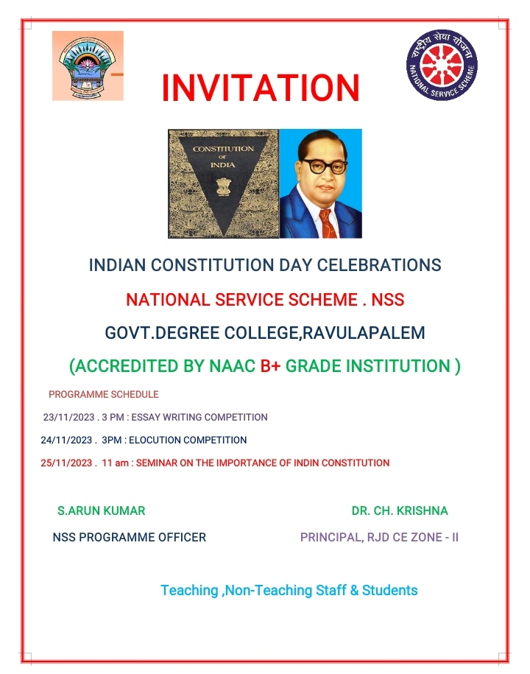

**MINUTES OF THE MEETING(24/011/2023)**

The Department of Political Science, Govt Degree College, Ravulapalem met with The Department of Political Science HOD Dr.G.Haribabu to conduct National Constitution Day for incluate the students among the constitution on 26th November .2024.

**Members Attended:**

1.Sri.S.Chinababu (Lecturer in Economics)

2.Dr.B. Haribabu I/C of the Department

3. Sri.V.Siddhardha Kumar (Lect in History)

4. Sri.S Rajendra prasad lec in Pol. Science

**MINUTES OF THE MEETING**

Keeping in view the significance of National Constitution Day Department of Political science proposed to celebrate and inculcate and inspiring the citizens towards Good governance.

.

**RESOLUTION**

It is unanimously resolved to request the principal to accord permission to conduct the Indian Constitution Day on 26th November 2024 in offline mode.

Signatures:

1. Sri.S.Chinababu (Lecturer in Economics)
2. Dr.G. Haribabu I/C of the Department
3. Sri.V.Siddhardha Kumar (Lect in History)

4. Sri.S Rajendra prasad lec in Pol. Science

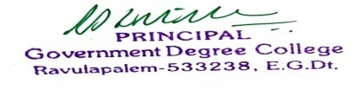

Principal

Letter to the Principal

The Principal, Dept of Political Science

Government Degree College, Government Degree College

Ravulapalem.

The Department of Political Science, Govt Degree College, Ravulapalem met with The Department of Political Science Conducted National Constitution Day for inculate and inspiring the citizens towards Good Governance .26th November.

Respected principal,

The Department of Political Science, Govt Degree College, Ravulapalem met with The Department of Political Science Conducted National Constitution Day on 26th November. Every year since 2015, National Constitution Day for inculcate and inspiring the citizens towards Good governance. So we the lecturer in Political Science are going to conduct National Constitution Day for inculcate and inspiring the citizens towards Good governance. So we the lecturers in Political Science and history are going to conduct National Constitution Day for inculcate and inspiring the citizens towards Good governance.

Thanking you sir,

Your’s faithfully,

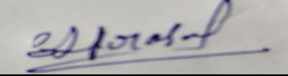

Sri S. Rajendra Prasad,

Lecturer in Political Science

CIRCULAR

All the staff and students are here by informed that on the occasion of National Constitution Day for inculcate and inspiring the citizens towards Good governance going to conduct this programme on November 26, 2023. So, all are requested to attend this programme in College Campus on November 26, 2023 at 11.30am and make it success.

Signatures:

1.I BA

2.II BA

3.III BA

4.I B.COM (G &CA)

5.II B.COM(G&CA)

6.III B.COM(G&CA)

7.I BSC (MPC, MPCS&IOT)

8.II BSC (MPC, MPCS&IOT)

9.III BSC (MPC, MPCS&IOT)

10.I BZC (CBZ &HBC)

11.II BZC (CBZ &HBC)

12.III BZC (CBZ &HBC)



Principal

Brief Report

Department of Political Science

Date & Time: 26-11-2023

Name of the Program: Indian Constitution Day

Resource Person: 1.Sri.A.Bhaskar 2.Sri.D.Balapratap-Senior Advocates, BAR Council, Kothapeta

Brief Report: The programme was organised by the Department of Political Science And National Service Scheme (NSS) Indian Constitution Day Celebration was done at Government Degree College, Ravulapalem on 26.11.2023 and a Seminar was also conducted on the Importance of Indian constitution. Senior Advocates of BAR council, Kothapeta Sri A.Bhaskar and Sri D.Balapratap explained the importance of Indian constitution to the students, distributed prizes and certificates to the Essay writing and Elocution competition winners

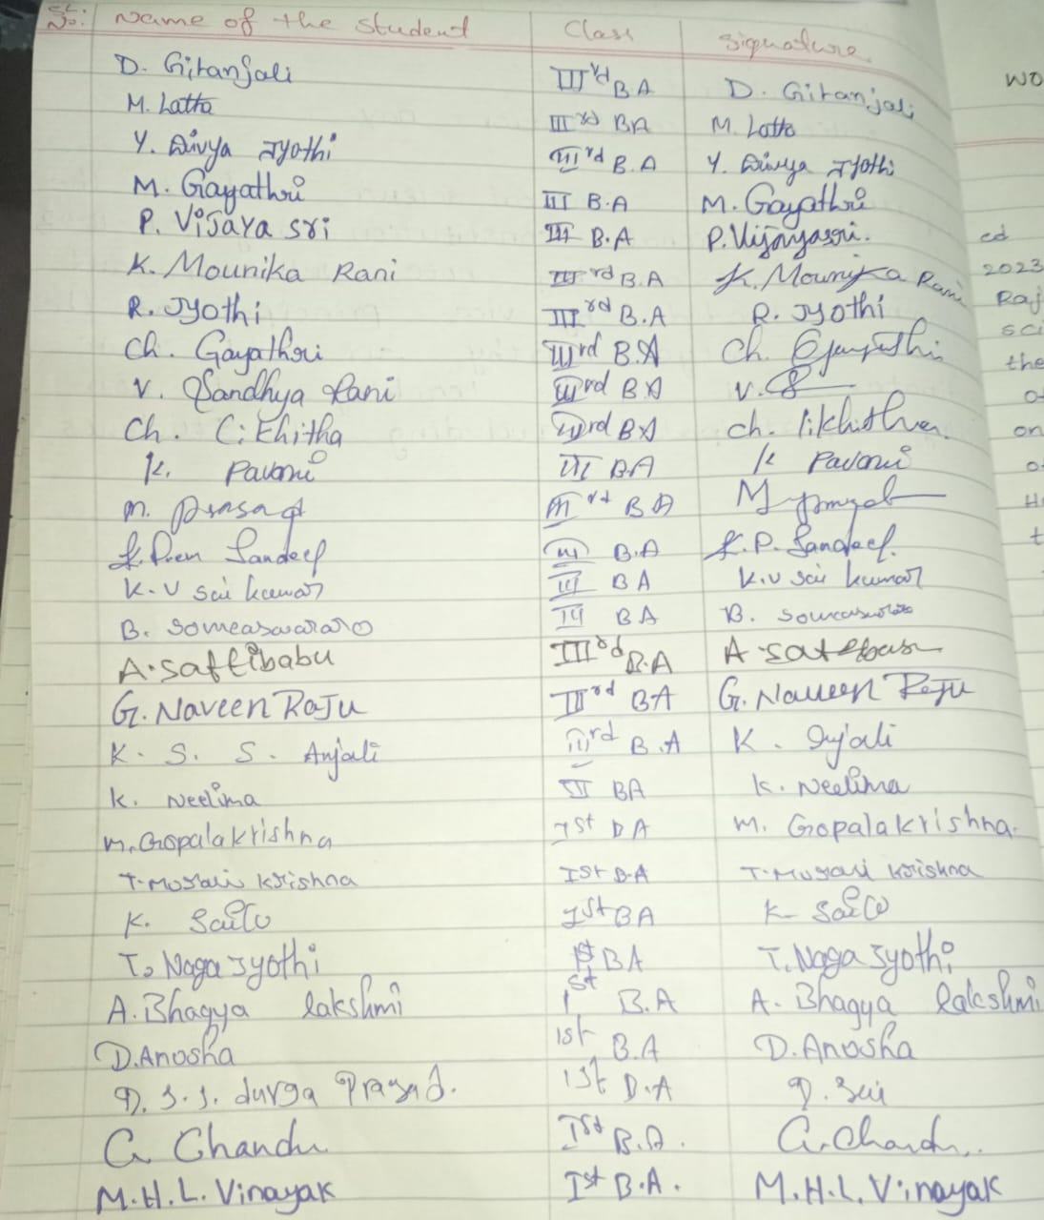

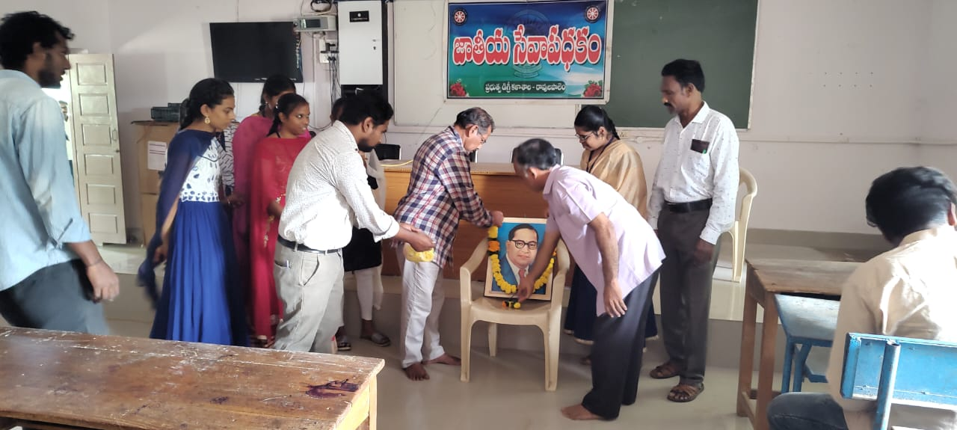

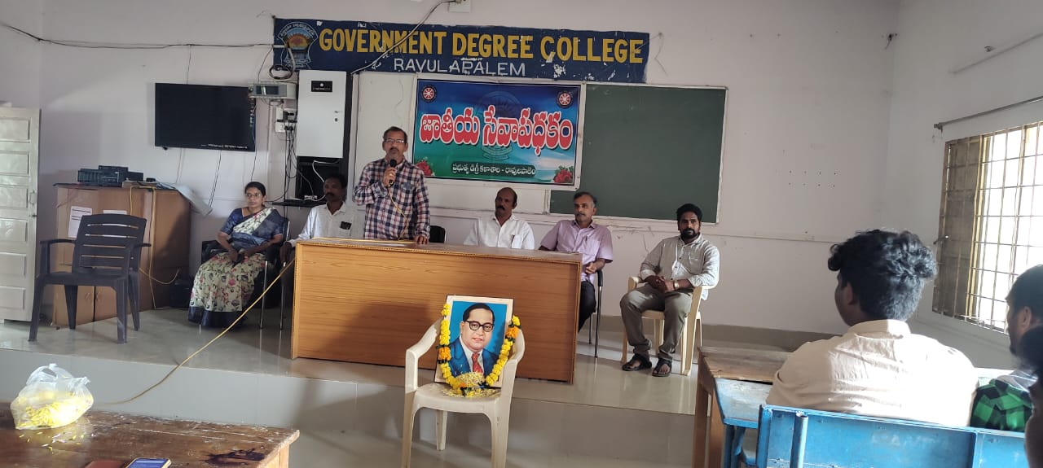

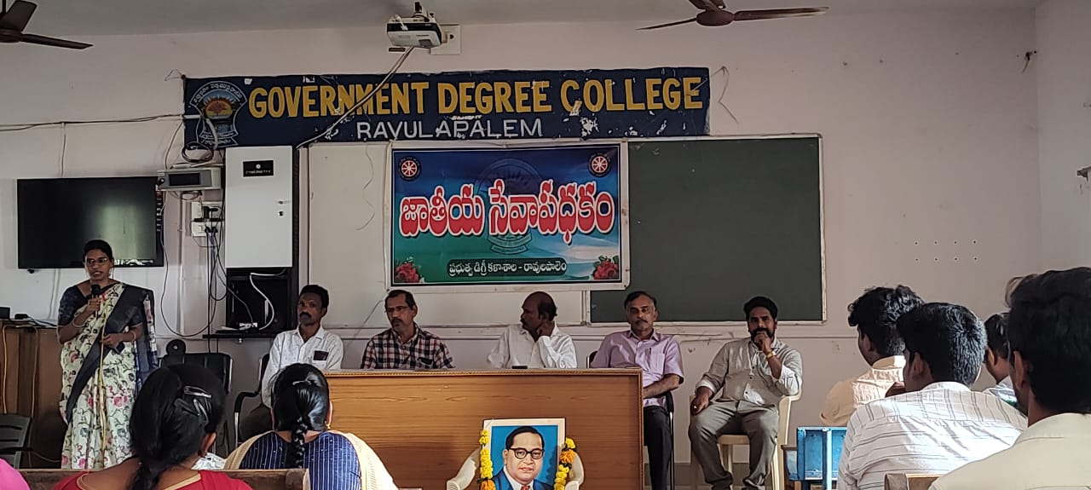

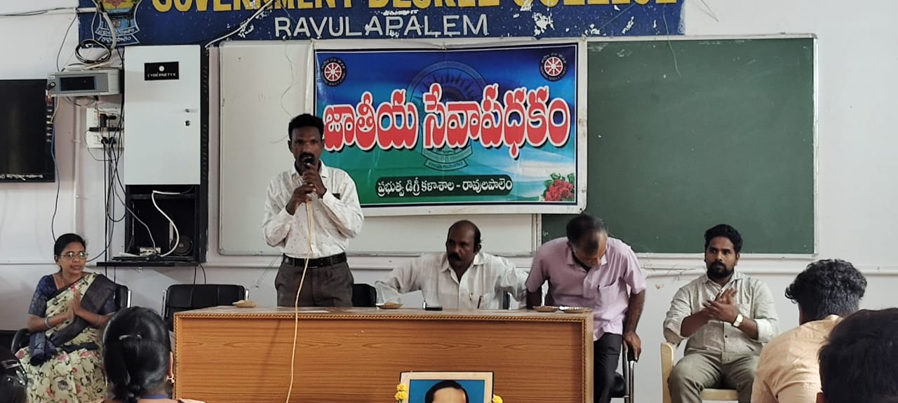

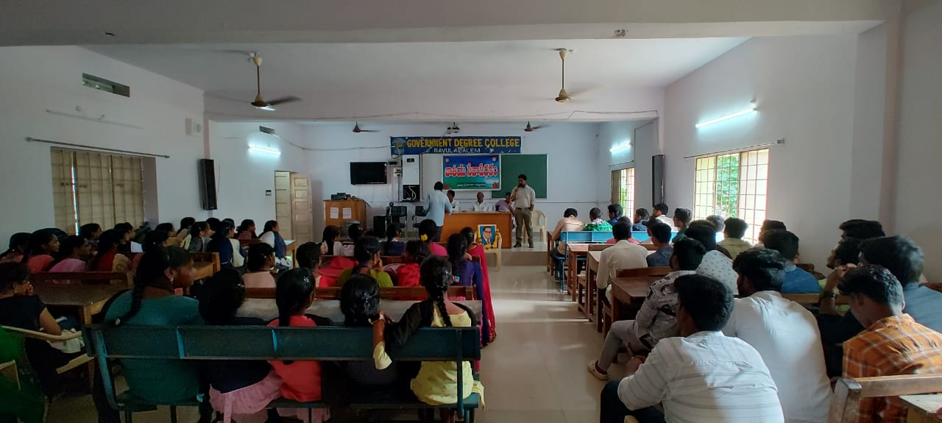

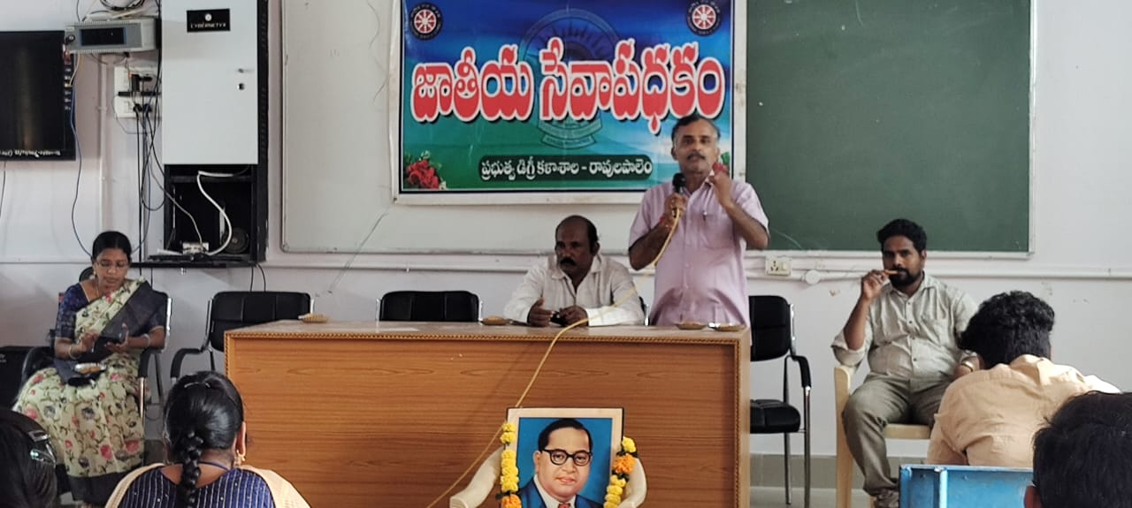

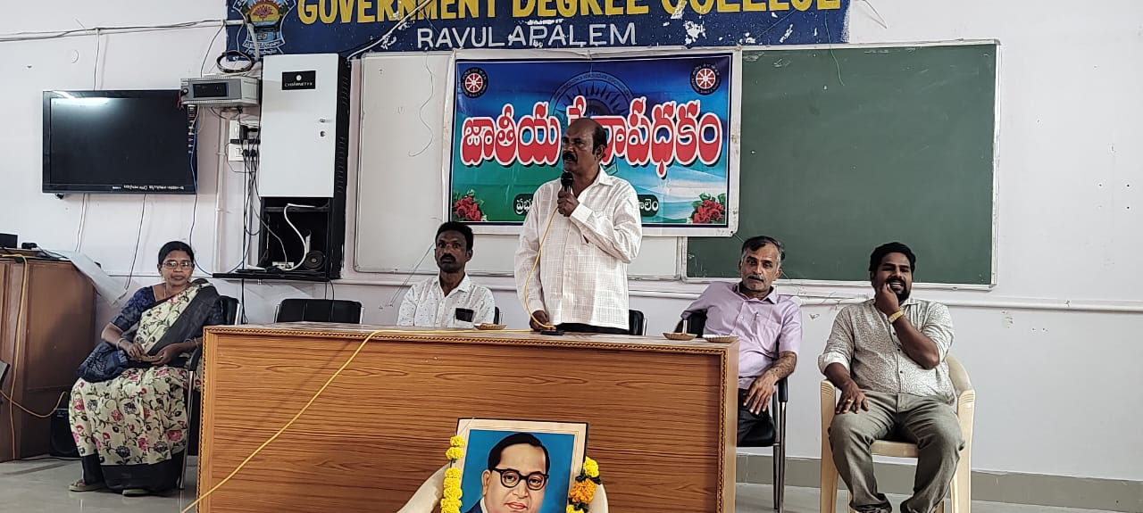

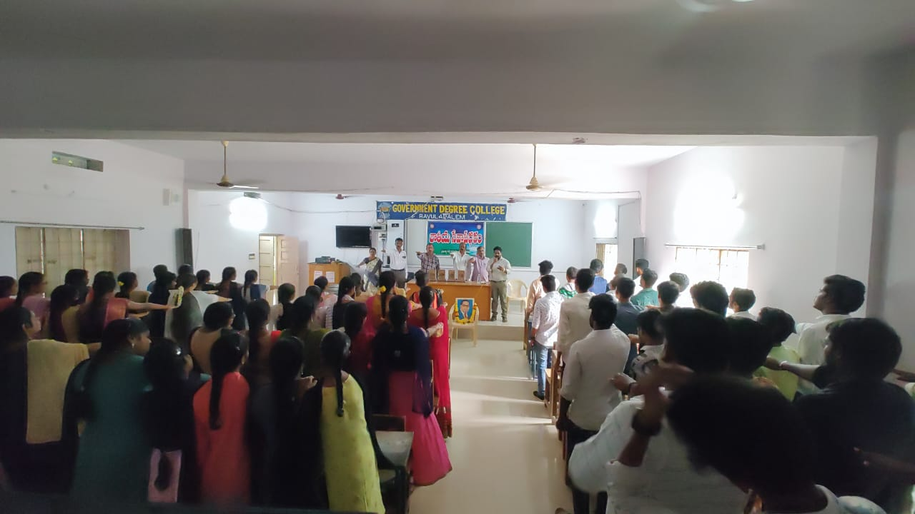

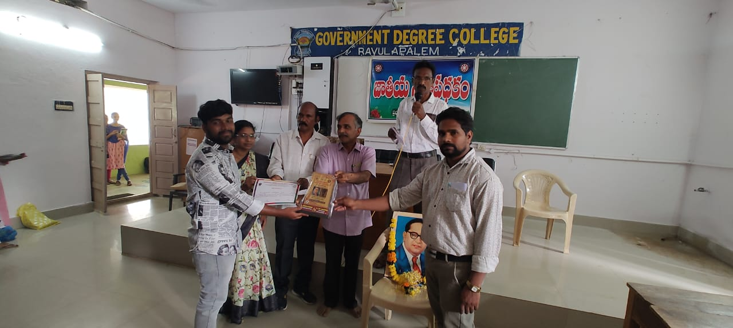

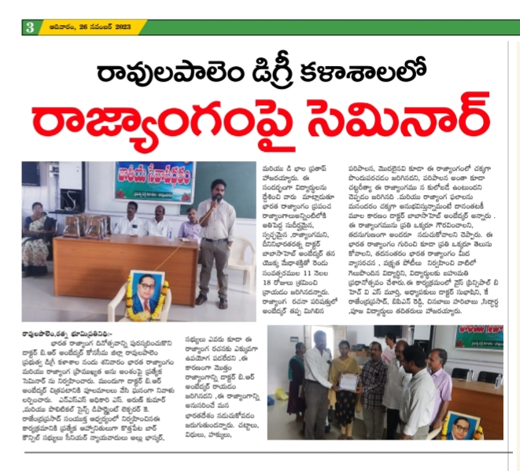



**Principal**